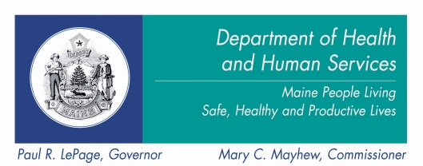 | SIM Payment Reform  Subcommittee Meeting  Date: December 10, 2013  Time: 3:00 pm - 5:00pm  Location: Governor Hill Mansion, Augusta
----- Agenda -----

Topics Lead Time

- Welcome and introductions Chair 10 min.

- Approval of Nov. 12th meeting notes Chair 5 min.

- Webinar: Michael Bailit, Bailit Health 60 min.

Developing an ACO Measure Set for Maine

- Question and answer session Chair 30 min.

- 2014 meeting schedule Chair 5 min.

- Public comment Chair 10 min.

For those members of the Payment Reform Subcommittee who cannot attend in person, please note that you can access the meeting via gotomeeting at the link below. For members of the ACI steering committee who would like to join the webinar, please see the instructions below.

- Please join my meeting.
https://www3.gotomeeting.com/join/836266774

- Use your microphone and speakers (VoIP) – a headset is recommended. Or, call in using your telephone

Dial 1+ (636) 277-0130
Access Code: 836-266-774
Audio PIN: Shown after joining the meeting

Meeting ID: 836-266-774

Please be advised that the first 24 participants who want to attend the entire subcommittee meeting remotely will be able to access though the gotomeeting site. If you are only interested in the webinar you may access that through the link below.

Topic: ACO Measures Presentation Date and Time:
Tuesday, December 10, 2013 3:15 pm, Eastern Standard Time (New York, GMT-05:00)
Event number: 667 221 564
Event password: 1234
Panelist password: The Event has no Panelist Password
Host key: 334478 (Use this to reclaim host privileges.)
Event address for attendees: https://mhca.webex.com/mhca/onstage/g.php?d=667221564&t=a
Event address for panelists: https://mhca.webex.com/mhca/onstage/g.php?d=667221564&t=p

